Hello Beaver Lake Families!
We hope you had a great summer and are settling back into the school schedule, homework, and all the fall activities!
Your PTSA is off and running and busy planning our fall events with much of the help coming from many of you! Already this year, the PTSA has provided volunteers for the Bulldog Business Day, First Day of School Schedule Handout, and Picture Make-up Day, and sponsored the Back to School Lunch for teachers and staff. Thank you to all our volunteers! Please watch for future volunteer opportunities – it’s a great way to meet and connect with other parents in the community!
To help keep these and many other programs going within the school, we continue to promote and ask our Bulldog families to support our “Pass the Hat” fundraiser. “Pass the Hat” is the PTSA’s only fundraiser and separate from the ASB Popcorn & Cookie Dough fundraiser that was recently launched. While the ASB fundraiser will help pay for student-focused activities including after school clubs, sports, and assemblies, the PTSA is focused not only on student events such as Trivia and BINGO nights, but also on needs within our kids’ classrooms that are not otherwise funded by the district or state through our Bucks for Bulldogs grant program. If you haven’t done so already, please consider donating to this cause by visiting our website: http://www.beaverlakeptsa.org. We will begin accepting Bucks for Bulldogs grant applications over the next few weeks from teachers and staff for programs/items that are not otherwise funded. Thanks to generous donations from our BLMS parents, many teachers have taken advantage of this great program. Over the past few years, well over $75,000 in grants have been given to BLMS from the PTSA – a very significant impact for our students and our entire BLMS community!
To hear more about what the PTSA has planned for this year and to learn how you can get involved, please join us at our General Membership Meetings held throughout the year. The first meeting is set for Tuesday, October 8th at 9:30am in the Portable B. In addition to PTSA news, you’ll have an opportunity to hear what’s happening in our school from our principal, Stacy Cho.
If you’d like to get involved with the PTSA or if you have any questions or feedback, please send an email to president@beaverlakeptsa.org. We are looking forward to a great year!
Thank you for your support!
Kindest regards,
Krystl McCandlish
PTSA President
“Like” us on Facebook at Beaver Lake Middle School PTSA
and find us at our website…www.beaverlakeptsa.org

Join today and help us reach 100% membership!
10 Reasons To Join PTSA
1. We need YOU!
2. Your child benefits. Studies show that when parents are involved it positively impacts their children’s education.
3. It’s a great way to meet other parents.
4. You’ll get to know the teachers and staff.
5. You will be better informed about school issues and activities.
6. The school benefits. PTSA supports the teachers and administration, which in turn creates a positive and caring atmosphere in the school.
7. You can make positive improvements at the school.
8. It is rewarding. Socializing with other parents and volunteering to do good for your child’s school is fun, healthy and rewarding!
9. You can be as involved as you want to be. We understand that people have busy schedules and appreciate any time you can spare.
10. We have fun!
PLEASE JOIN NOW
The school year is off to a great start with the help of the following volunteers: Bulldog Business Day: Amy Sparks
Angela Fischer
Letchmi Kanasu
Pavana Jayandra
Lisa Peppin
Sonal Vora
Yvette Artman

Student Schedule Handout: And Amy Sparks, Chris Edwards, Janet Bien, Jessica Mills, Nadia Ali, Sunshine Kragh, Shelly Compton, Deepa Majumder Thank

Issaquah Schools Foundation is an important resource at all 24 schools supporting programs like after school academic programs, robotics, dedicated fine arts, Cultural Bridges, basic student needs and homework help! We also provide grants to teachers and schools that benefit every student and every school in the district. Step Up for Kids and donate to our fall campaign HERE !

UPDATES

VOICE Mentor Program:
Over the past 15 years, the Issaquah Schools Foundation is proud to have seeded, nurtured, and grown the VOICE (Volunteers Of Issaquah Changing Education) mentoring program.

We want to share that with the success of this program, VOICE has transitioned from the Foundation to the Issaquah School District this school year.

Because of YOU - our volunteers, donors and Foundation staff, VOICE has helped over 1000 students, and continues to impact hundreds of students each year with over 300 mentors.

If you've been involved with the VOICE mentor program in the past, you will experience very little, if any, change in how things are managed. There will be no disruption of matches during this transition, and any changes will continue to be communicated promptly regarding operations of the program.

If you have any questions about this change please phone or email VOICE at 425-837-7222 or VOICE@issaquah.wednet.edu.

- October 2nd (Wed.) – Dining for Kids @ Agave Cocina
- October 4th (Fri.) - ASB Fundraiser, Turn-In Day #2
- October 8th (Tues.) - 9:30am: PTSA General Membership meeting - Portable B
- October 14th (Mon.) – Teacher Work Day – No School
- October 16th (Wed.) – Mid-Tri

Volunteers

We had our FIRST Robotics informational meeting on Friday 9/27 at 4:30 PM in CTE room. Thank you all for the interest in our FIRST Robotics program! It was filled to capacity! We had 10+ students interested in the FTC program and over 30 students experienced the FLL program! Feel free to spread the word. We do have room for more. The most important task right now - besides creating and testing robots - is to register for our new club. You cannot be considered part of the club unless this form is submitted. Our normal meeting days are Fridays from 3:00 - 5:00. These hours may be extended in the future depending on deadlines. I do feel that adding another day will allow more students and parent volunteers to participate, so I'll be adding either Monday or Tuesday from 3:00 - 5:00 to the schedule. Parents, I've added a quick question to the registration form for you to help decide which day works best your you and your student.
Please REGISTER before 9:00 PM Thursday, 10/3/2019 and submit the FORM.
Additionally, there is a $25.00 registration fee for each club member, payable the BLMS's bookkeeper. PLEASE ALLOW 2 - 3 DAYS BEFORE SUBMITTING PAYMENT FOR THIS TO BE SET UP! I will follow up with another blog when payments are ready to be accepted. If this is a hardship for your family, please reach out to Kevin Christensen, FIRST Robotics Advisor. Scholarships are available.

Finally, I'd like to solicit for mentors and volunteers. The more students we have, the more mentors and volunteers we need. Mentors do not need to have any direct or indirect robotics, engineering, or coding experience. Mentors can be a person of any age but usually an adult, teaching others what they know; they bring either technical or non-technical expertise to the team; and provide an opportunity for students to learn directly through experiences. Mentors work directly with the students. Ideally, we should have 2 mentors per team each meeting. Volunteers are needed to help shuttle kids to events, bring snacks during weekday meetings, help spread the word about the club to other parents, help keep this website up to date, create a newsletter or blog entry, etc. I have created a list to register for a mentor and volunteer slots. Please review the available mentor and volunteer opportunities and complete the online signup form.

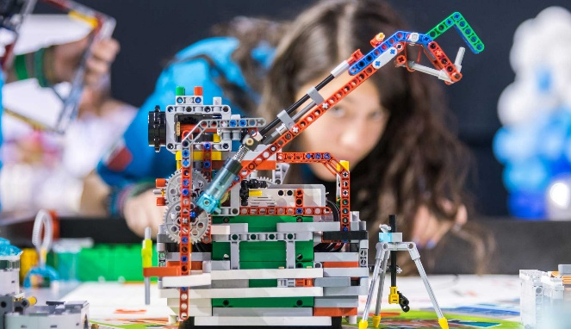
Thank you!
Mr. Christensen,
Advisor FIRST Robotics Club
Website

